Ideation Phase
Define the Problem Statements

Date | 22 June 2026
Team ID
Project Name | Automated Network Request Management System
Maximum Marks | 2 Marks

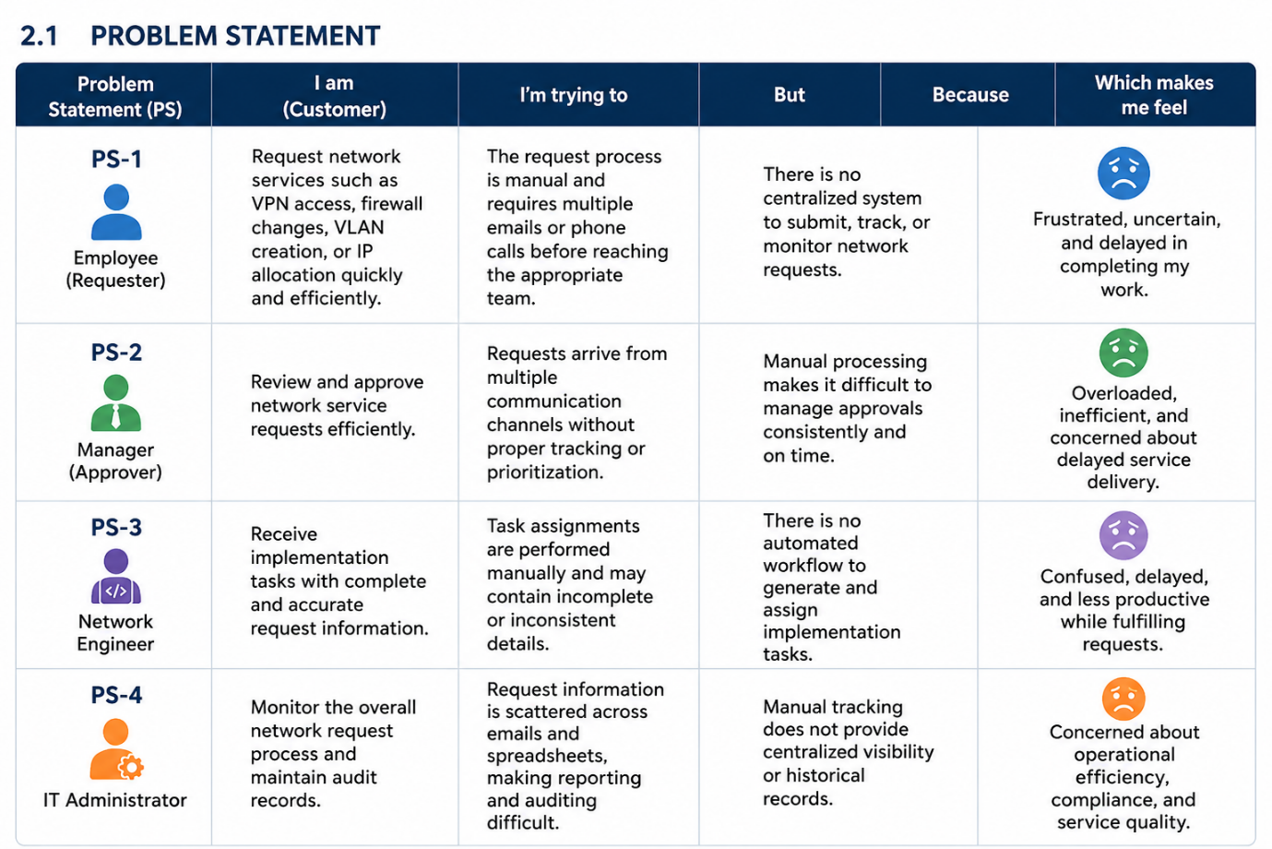
Reference: https://miro.com/templates/customer-problem-statement/

2. PROJECT OVERVIEW
2.1 Problem Statement
Problem Statement (PS) | I am (Customer) | I'm trying to | But | Because | Which makes me feel
PS-1 | Employee (Requester) | Request network services such as VPN access, firewall changes, VLAN creation, or IP allocation quickly and efficiently. | The request process is manual and requires multiple emails or phone calls before reaching the appropriate team. | There is no centralized system to submit, track, or monitor network requests. | Frustrated, uncertain, and delayed in completing my work.
PS-2 | Manager (Approver) | Review and approve network service requests efficiently. | Requests arrive from multiple communication channels without proper tracking or prioritization. | Manual processing makes it difficult to manage approvals consistently and on time. | Overloaded, inefficient, and concerned about delayed service delivery.
PS-3 | Network Engineer | Receive implementation tasks with complete and accurate request information. | Task assignments are performed manually and may contain incomplete or inconsistent details. | There is no automated workflow to generate and assign implementation tasks. | Confused, delayed, and less productive while fulfilling requests.
PS-4 | IT Administrator | Monitor the overall network request process and maintain audit records. | Request information is scattered across emails and spreadsheets, making reporting and auditing difficult. | Manual tracking does not provide centralized visibility or historical records. | Concerned about operational efficiency, compliance, and service quality.

